Relfecting on SenseCam: A wearable camera that stimulates recall and aids memory impairments

Steve Hodges  
School of Computing & Communications  
Lancaster University  
Lancaster, UK  
steve.hodges@lancaster.ac.uk

Abstract—SenseCam was an idea for a wearable camera that automatically captures wide-angle still images every thirty seconds or so. With an all-day battery life, SenseCam was intended allow the wearer to capture a first-person record of an event or entire day. Here we present what a prototype SenseCam might look like if it were based on today’s technologies. Early evaluation of a prototype similar to this by a patient with amnesia showed that reviewing SenseCam images can elicit true autobiographical recall. This genuine feeling of remembering has the potential to enhance the wearer’s quality of life.

# Introduction

Human memory is all too fallible – most of us frequently forget things. Of course, for those with clinically diagnosed memory disorders these issues are particularly troublesome. One example of such a diagnosis is acquired brain injury, which occurs either through disease or a traumatic incident. Another example, perhaps of more significance in an aging population, is neurodegenerative disease such as Alzheimer’s Disease which damages the brain such that there is no possibility of recovery.

The effects of acquired brain injuries, neurodegenerative diseases and aging in general vary greatly between patients. Patients with moderate-to-severe memory problems may fail to remember future intentions (prospective memory), which impacts their ability to look after themselves on a day-to-day basis. A failure of past (retrospective) memory, and in particular episodic or autobiographical memory (i.e. the memory of things done rather than facts learned) is critical for a full quality of life.

This paper presents a prototype of a wearable digital camera called SenseCam designed to keep a digital record of the events that the wearer experiences. The aim of the device is to take these recordings automatically, without any user intervention and therefore without any conscious effort. Having captured a digital record of an event, this can subsequently be reviewed by the wearer. The hope is that this will stimulate their memory of that event.

# Related work

The use of external memory aids to compensate for memory deficits is a valuable and effective ways to aid rehabilitation (see [9] for a review). However, at the time SenseCam was first envisaged [6], few external memory aids were available to improve memory of past experiences. Perhaps the two most obvious examples were: photographs and written diaries, both of which have been shown to stimulate memory for past events [1], [9]. It is not surprising that photographs act as a memory stimulant – autobiographical memory is thought to be rich in visual imagery [2], [3].

Wearable cameras have an established role in ubiquitous and wearable computing research dating from the 1940s [5] and today are widely available as consumer products (search ‘bodycam’ on Amazon). When SenseCam was conceived 20 years ago this was not the case! None-the-less, the research literature did include several examples. Mann [10] described the implementation of WearCam, a wearable head-mounted video camera, which can be user-triggered to take video of interesting events. HP’s Casual Capture prototype [4] was an early always-on wearable video camera. StartleCam [7] comprises of a wearable video camera, a computer (housed in a rucksack), and offboard skin conductance sensors.

# A first prototype

The motivation for SenseCam was to unify and extend the body of work at the time (as reviewed above) and to create a low-power and easy-to-operate wearable camera which was small and light enough to be worn on a lanyard around the wearer’s neck. Its wide-angle lens allows it to capture most of the wearer’s field of view, which it did automatically on a 30 second timer. It also had a number of other sensors built into it, such as light level, motion and temperature, and the processor periodically took readings from these sensors and also recorded them. At the end of an event or an entire day, the images and the sensor data could be downloaded from the camera to a PC over USB.

If a prototype SenseCam-like device were to be built today, it could be based on an Arduino Uno board and an OV7670 camera module. These components are readily available, for example on <https://amazon.co.uk>. A 1.8” TFT LCD connected to the Arduino over SPI could help with testing by allowing debug information and images to be shown, but that would not be needed for the final device. Example code to interface with the camera module and the display is available online at <https://github.com/indrekluuk/LiveOV7670>. The other sensors mentioned above could be sourced from Amazon, Farnell or RS Components and could be readily interfaced with the Arduino.

[NB images in this section are from [https://circuitjournal.com  
/arduino-ov7670-10fps](https://circuitjournal.com/arduino-ov7670-10fps) by Indrek Luuk. They are used to illustrate what a prototype SenseCam might look like if created today.]

## Camera-to-Arduino wiring diagrams

This first figure shows how the Arduino controls the camera module:

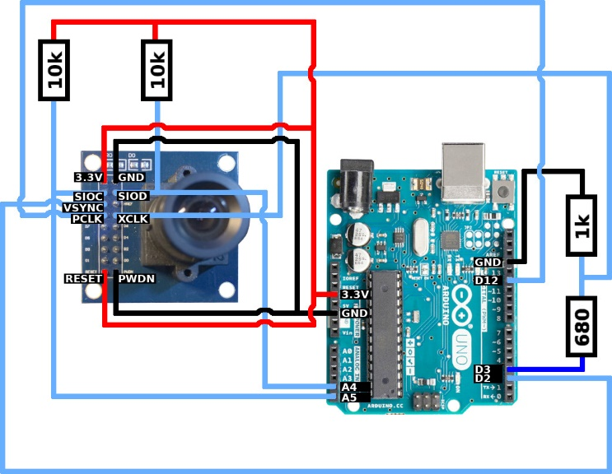

While the data pins are connected as follows:

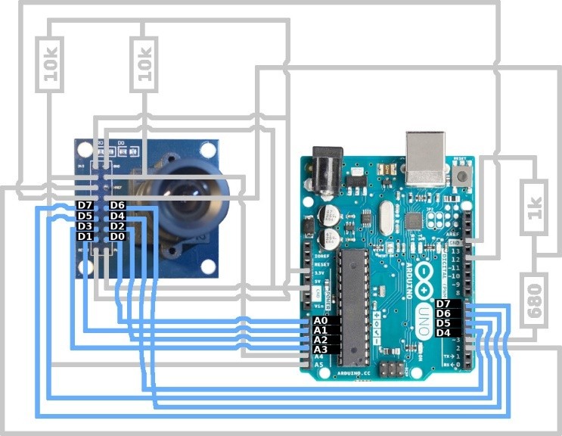

## Photo of prototype

A prototype based on the above components and wiring was built using a standard breadboard, shown below. In addition to the Arduino processor, it includes the camera and a display. As mentioned above, no other sensors have been integrated yet.

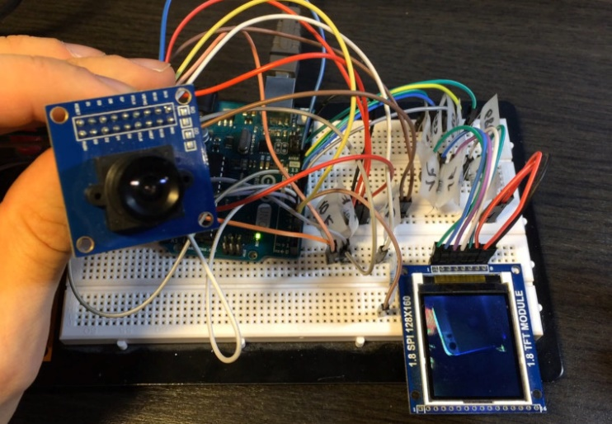

# Envisaged next prototype iteration

The prototype illustrated above is a bit too big for the envisaged wearable form factor. It’s also powered over the Arduino USB connection, whereas the SenseCam use-case requires integration of a rechargeable battery. Finally, SenseCam needs some kind of mass storage, such an SD card, for keeping an entire day’s images.

Taking all the above into consideration, a wearable form factor something like the following would be ideal:

# Responsible innovation

If SenseCam can provide a new way for people with memory impairments to start remembering things such as events, places and even acquaintences – things that might otherwise be forgetton forever – that could have a tremendously positive impact in society. So the potential up-side of this technology is significant.

However, as with all electronic devices, there is a potential environmental cost to producing and operating a SenseCam. To mitigate these, the device should be designed to support fault diagnosis and repair, thereby extending its operating lifetime and reducing the need for replacement devices in the event of any faults or damage. We are also keen to evaluate using a recyclable and/or biodegradable material – such as PLA – for the SenseCam’s enclosure.

Due to the relatively low power consumption of SenseCam, the environmental operating cost is also low, and is further mitigated through the use of a rechargeable battery.

# Author bio

I am a researcher and engineer in the field of embedded and interactive devices. I aspire to combine these skills with creative design to conceive novel hardware solutions that make computers more useful, engaging and inclusive.

My technical expertise includes interactive systems, wireless communications, radio-frequency identification, novel sensing and displays, embedded camera systems, location systems, energy management, security, wearable technologies and rapid prototyping. I have built tools and experiences that span domains such as the internet of things, mobile & ubiquitous computing, assistive technologies and education. I’m good with electronics design, PCB layout and 3D mechanical design, I’m capable soldering by hand, and I’ve developed embedded firmware in C, C++ and assembler.

# Acknowledgments

The SenseCam project was a collaboration between many people around the world. The first publication which presents SenseCam was a collaboration between Microsoft researchers in Cambridge, UK and Silicon Valley, US [6]. The hardware was subsequently revised several times, and software was developed specifically for reviewing image sequences in a lightweight manner. The paper that reports many of these technology improvements and illustrates their benefits as experienced by the first memory-loss patient to use SenseCam was published at UbiComp 2006 [8]. Subsequently to that, Microsoft Research seeded a large number of collaborations around the world which sought to enhance the technology and/or to evaluate it in a wide range of scenarios of use, see <http://aka.ms/sensecam> for more information. I am one in a cast of many that was fortunate to be involved.

# References

1. Bourgeois, M.S.: Enhancing conversation skills in patients with Alzheimer’s disease using a prosthetic memory aid. Journal of Applied Behavior Analysis, 23 (1990), 29-32.
2. Brewer, W. F.: What is autobiographical memory? In D. Rubin (Ed.), Autobiographical Memory (pp. 25-49). Cambridge: Cambridge University Press, 1986.
3. Brewer, W. F.: Qualitative analysis of the recalls of randomly sampled autobiographical events. In M. M. Gruneberg, P. E. Morris, & R. N. Sykes (Eds.), Practical Aspects of Memory: Current Research and Issues (Vol. 1, pp. 263-268). Chichester: Wiley, 1988.
4. Broersma, M.: Taking the shutterbug out of the picture, <https://www.cnet.com/culture/taking-the-shutterbug-out-of-the-picture/>, May 2003.
5. Bush, Vannevar,. As We May Think, The Atlantic Monthly, 176(1), July 1945, 101-108.
6. Gemmell, Jim, Williams, Lyndsay, et al.: Passive Capture and Ensuing Issues for a Personal Lifetime Store, Proceedings of The First ACM Workshop on Continuous Archival and Retrieval of Personal Experiences (CARPE '04), Oct. 15, 2004, New York, NY, USA, pp. 48-55.
7. Healey, J. and Picard, R. StartleCam: A Cybernetic Wearable Camera. Proceedings of the International Symposium on Wearable Computing, Pittsburgh, Pennsylvania, 19-20 October 1998, pp. 42-4.
8. Hodges, S. et al: SenseCam: A Retrospective Memory Aid, Ubicomp 2006, LNCS 4206, pp. 177-193, 2006. © Springer-Verlag Berlin Heidelberg 2006.
9. Kapur, N. et al.: External memory aids and computers in memory rehabilitation. In A.D. Baddeley, M.D. Kopelman & B.A. Wilson (Eds.), The Hand-book of Memory Disorders, Second Edition (pp. 757-784). Chichester, UK: John Wiley, 2002.
10. Mann, S.: Wearcam (The Wearable Camera), Proceedings of the International Symposium on Wearable Computers, pages 124-131, 1998..